

# Data Analyst Nanodegree

# Project #01 [Exploring Weather Trends](https://classroom.udacity.com/nanodegrees/nd008-mena-connect/parts/e2b3ff5a-3706-4554-a8b2-8ae78dbed63a" \l "lesson-card-scroll-target-33aed7ac-5333-4051-a15b-19a9ab499e27)

# 

Name: Marwan Saeed Alsharabbi

Date: 20-March-2020

2020

**Introduction**

**Exploring Weather Trends - Project Instructions**

**Summary**

In this project, you will analyze local and global temperature data and compare the temperature trends where you live to overall global temperature trends.

**Instructions**

Your goal will be to create a visualization and prepare a write up describing the similarities and differences between global temperature trends and temperature trends in the closest big city to where you live. To do this, you’ll follow the steps below:

**Extract the data** from the database. There's a workspace in the next section that is connected to a database. You’ll need to export the temperature data for the world as well as for the closest big city to where you live. You can find a list of cities and countries in the city_list table. To interact with the database, you'll need to write a SQL query.

Write a SQL query to extract the city level data. Export to CSV.

Write a SQL query to extract the global data. Export to CSV.

**Open up the CSV** in whatever tool you feel most comfortable using. We suggest using Excel or Google sheets, but you are welcome to use another tool, such as Python or R.

**Create a line chart** that compares your city’s temperatures with the global temperatures. Make sure to plot the *moving average* rather than the yearly averages in order to smooth out the lines, making trends more observable (the last concept in the previous lesson goes over how to do this in a spreadsheet).

**Make observations** about the similarities and differences between the world averages and your city’s averages, as well as overall trends. Here are some questions to get you started.

Is your city hotter or cooler on average compared to the global average? Has the difference been consistent over time?

“How do the changes in your city’s temperatures over time compare to the changes in the global average?”

What does the overall trend look like? Is the world getting hotter or cooler? Has the trend been consistent over the last few hundred years?

**Submission**

Your submission should be a PDF that includes:

**An outline** of steps taken to prepare the data to be visualized in the chart, such as:

What tools did you use for each step? (Python, SQL, Excel, etc)

How did you calculate the moving average?

What were your key considerations when deciding how to visualize the trends?

**Line chart** with local and global temperature trends

At least **four observations** about the similarities and/or differences in the trends

**Rubric**

A Udacity reviewer will assess your project based on the criteria in the [**project rubric**](https://review.udacity.com/#!/rubrics/1125/view). Use the rubric as a guide while you complete the project, then give yourself a quick self-assessment before you submit it.

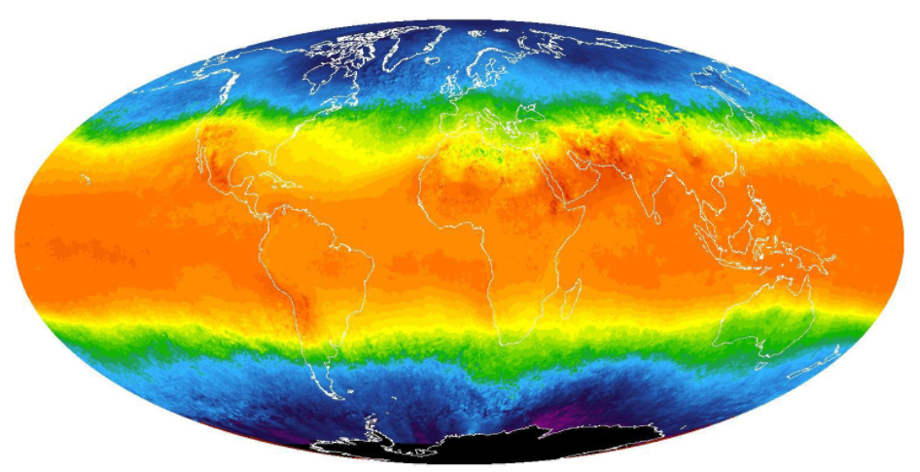

# Exploring Weather Trends - Project

In my first project to analyze data according to project requirements, I will use five steps:

1- Data Extraction

2- Data Cleaning

3- Data Exploration

4- Data Visualization

5- Used in the implementation of the project by Python, Alteryx and Excel

1- Data Extraction

**SQL** used to extract the data from the database schema:

1- Query#1 query for global_data

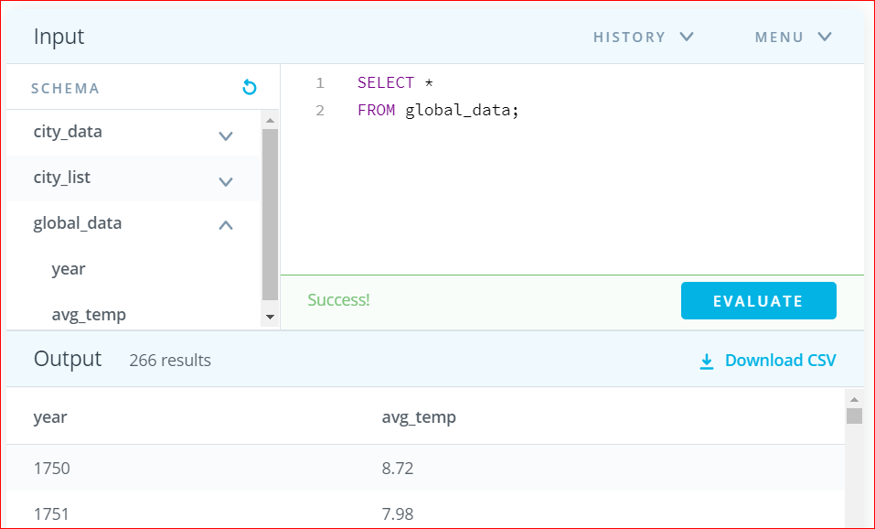

2- Query#2 query for city_data

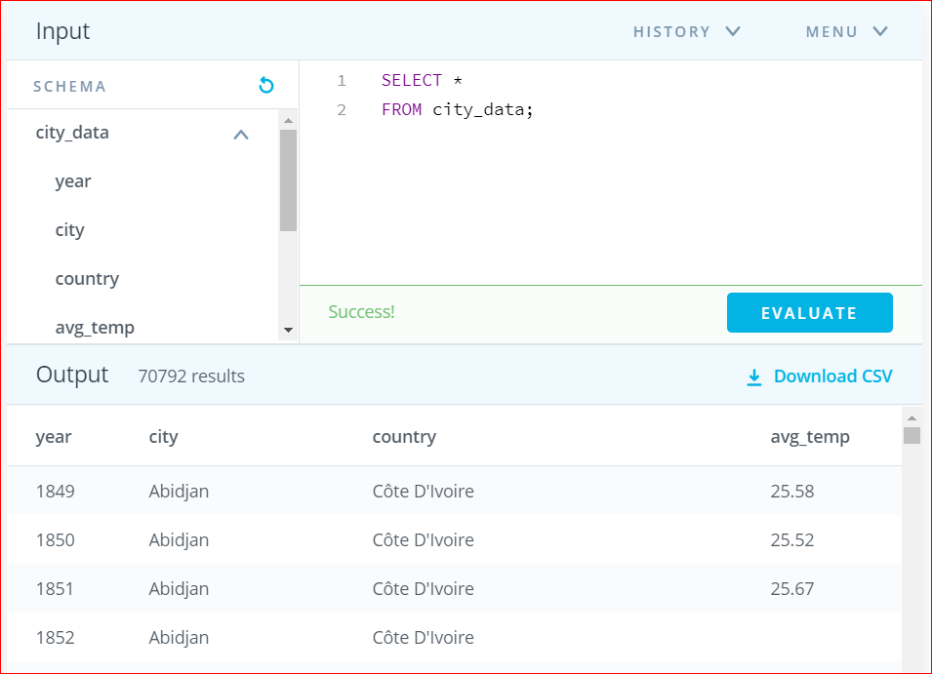

3- Query#2 query for Riyadh City

Extracting data for the city of Riyadh in the Kingdom of Saudi Arabia (the country in which I live), my country of origin, Yemen I will use this data to analyze the project

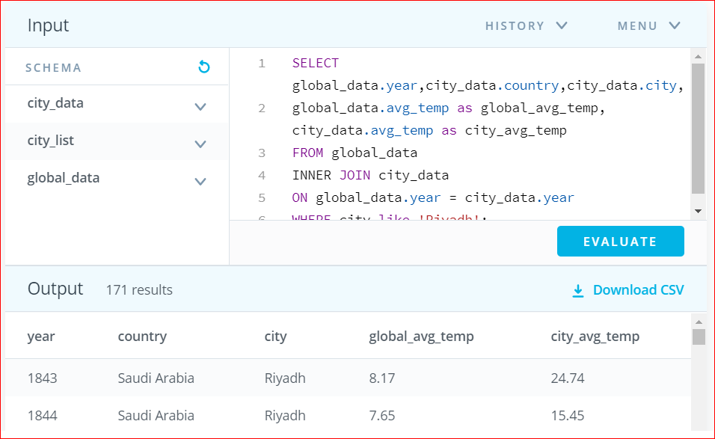

Within WHERE statement Riyadh city with the name Where city like 'Riyadh

2- Data Cleaning

After the data was extracted to an Excel file according to the previous query, I got some missing values in the column city_avg_temp the missing values were replaced with the median of the data and the total number of row 171

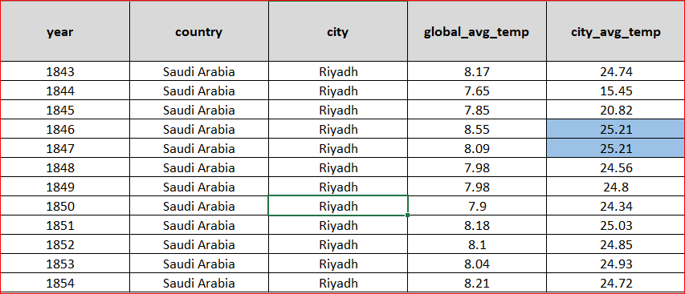

3- Data Exploration

According to the project requirements using the moving average, and in order to better visualize, I calculated the moving average between Global_avg_temp and Riyadh city_avg_temp 5 years_MA 10 years_MA 15 years_MA

Basics of Moving Averages

Moving averages are used and discussed quite commonly by technical analysts and traders alike. . A moving average can help an analyst filter noise and create a smooth curve from an otherwise noisy curve. It is important to note moving averages lag because they are based on historical data, not current price.

Moving Averages Are a Part of Most Trading Platforms! Source: Unsplash

The most commonly used Moving Averages (MAs) are the simple and exponential moving average. Simple Moving Average (SMA) takes the average over some set number of time periods. So a 10 period SMA would be over 10 periods (usually meaning 10 trading days).

The Simple Moving Average formula is a very basic arithmetic mean over the number of periods

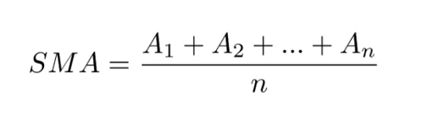

Calculating Correlation coefficient for Global_temp and Riyadh_temp City

Correlation coefficient calculated on the 5 years, 10 years ,15 years moving averages for the global_avg_temp and city_avg_temp

Correlation coefficient for Global_avg_temp and City_avg_temp= 0.611409

Correlation coefficient for Global_avg_temp and City_avg_temp(5 years/MA) =0.812437

Correlation coefficient for Global_avg_temp and City_avg_temp(10 years/MA)=0.899898

Correlation coefficient for Global_avg_temp and City_avg_temp(15 years/MA)=0.921657

We note from the results there is a positive correlation between the variables

4- Data Visualization

I plotted a line Visualization with the temperature for the city_avg _temp riyadh and globel_avg_temp in X-axis moving average values and years in Y-axis

First use by Python

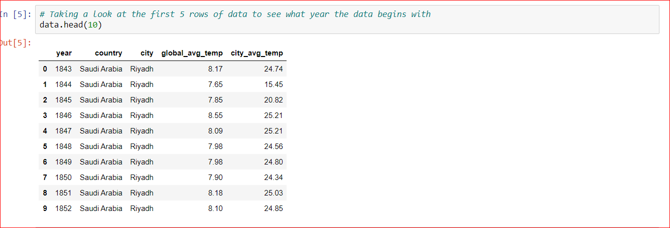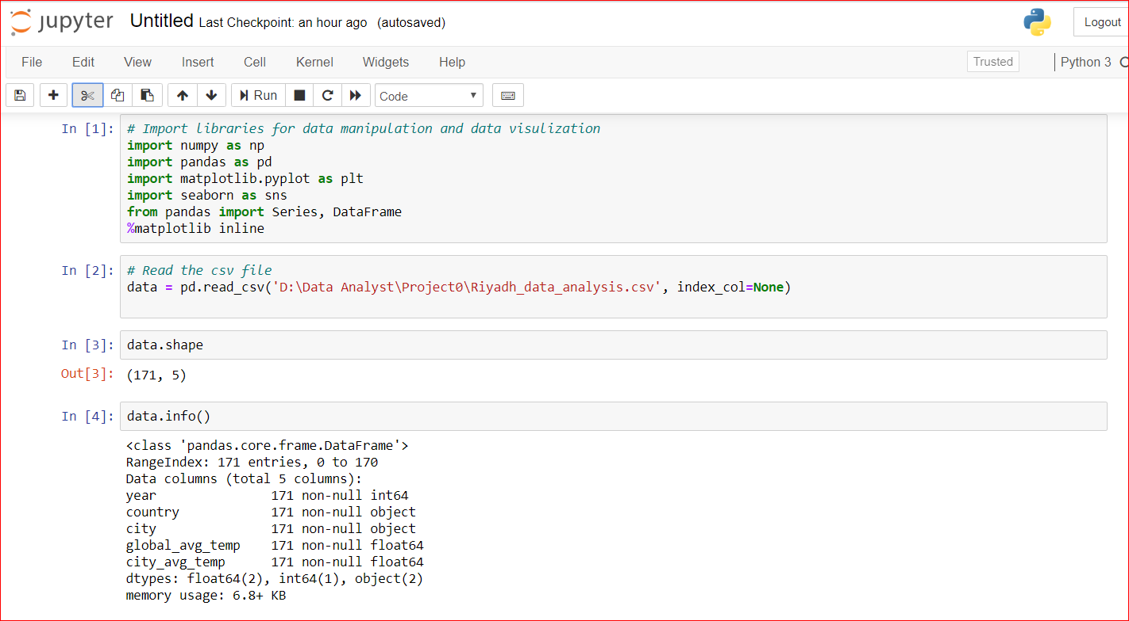

by Visualization Global_avg_temp and City_avg_temp(5,10,15 years/MA)

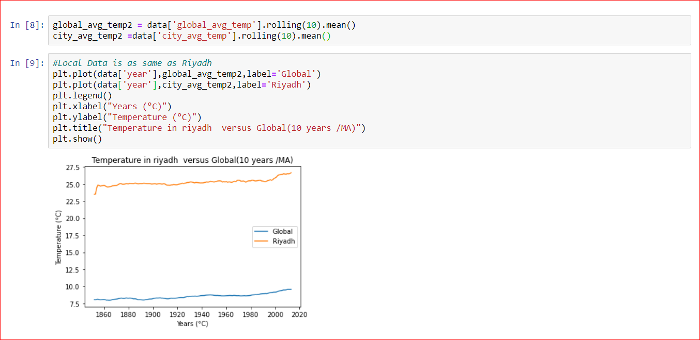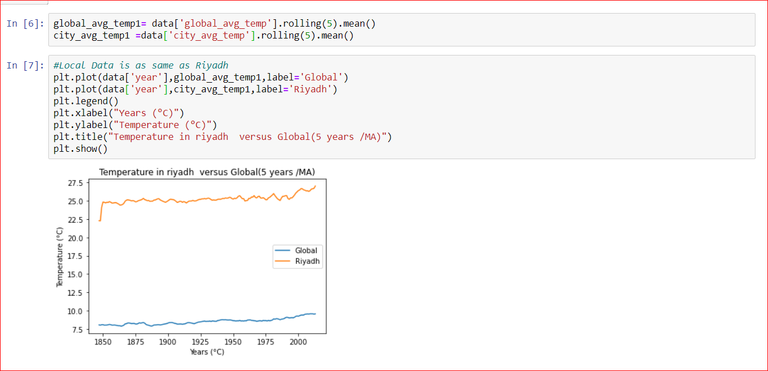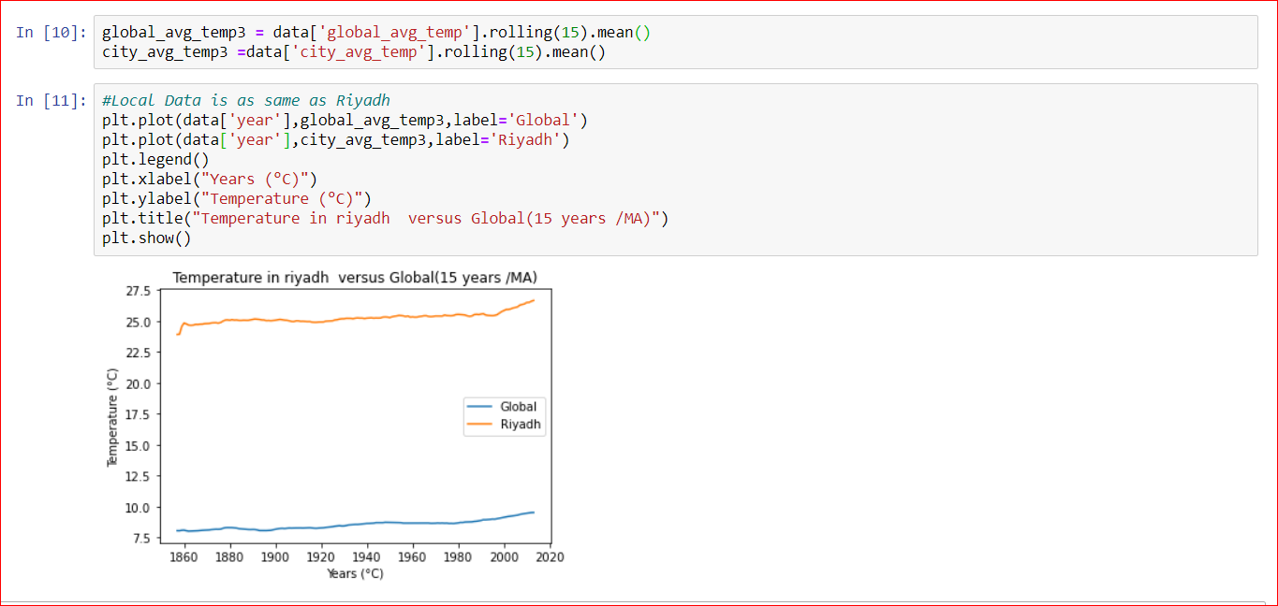

Second use by alteryx

Work flow

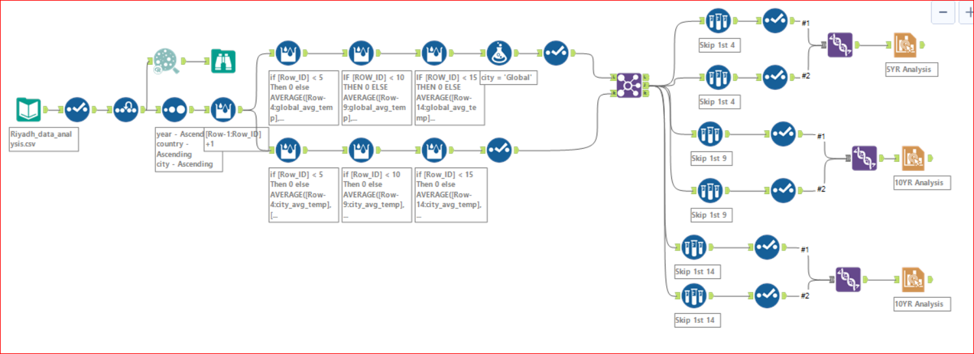

Scatterplot used to see the linear relationship between glopal_avg_temp and city_avg_temp

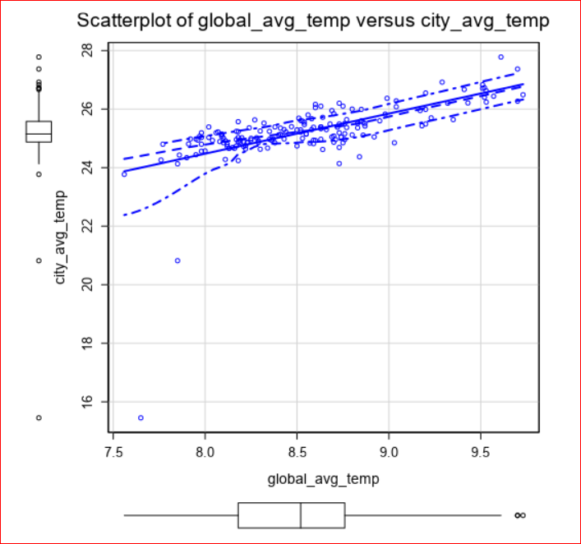

Visualization Global_avg_temp and City_avg_temp(5,10,15 years/MA)

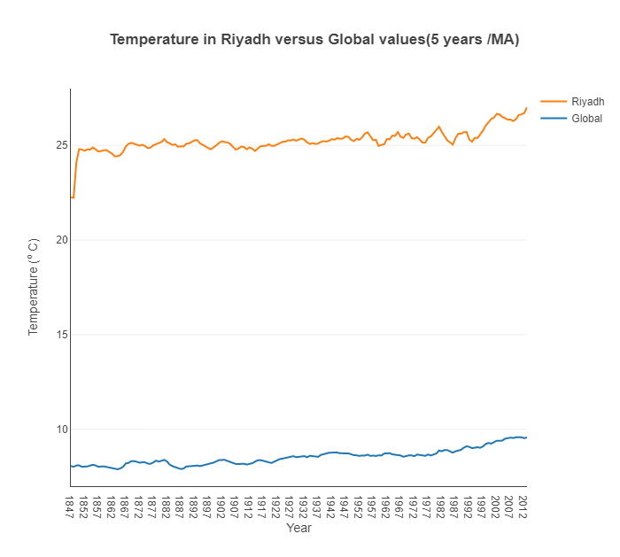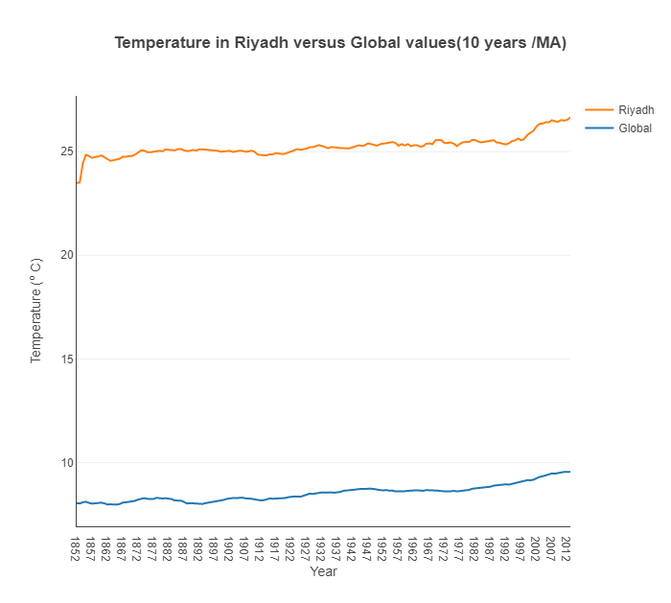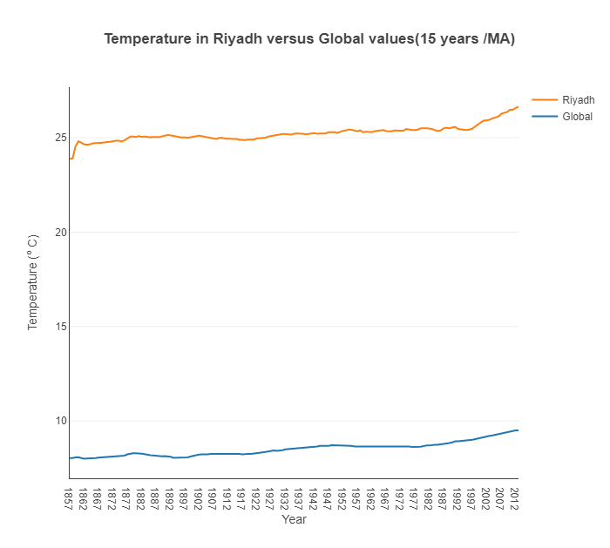

Third use by excel

I used data analysis tool in excel

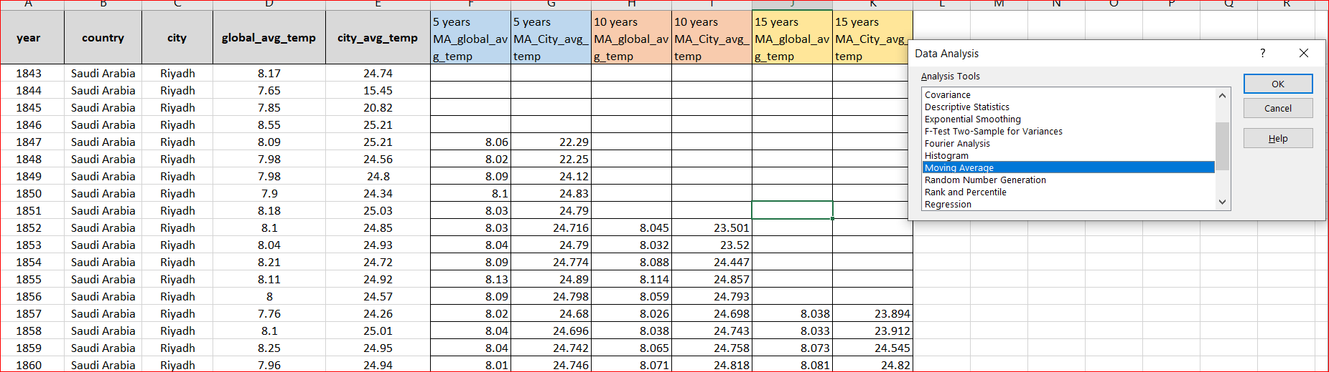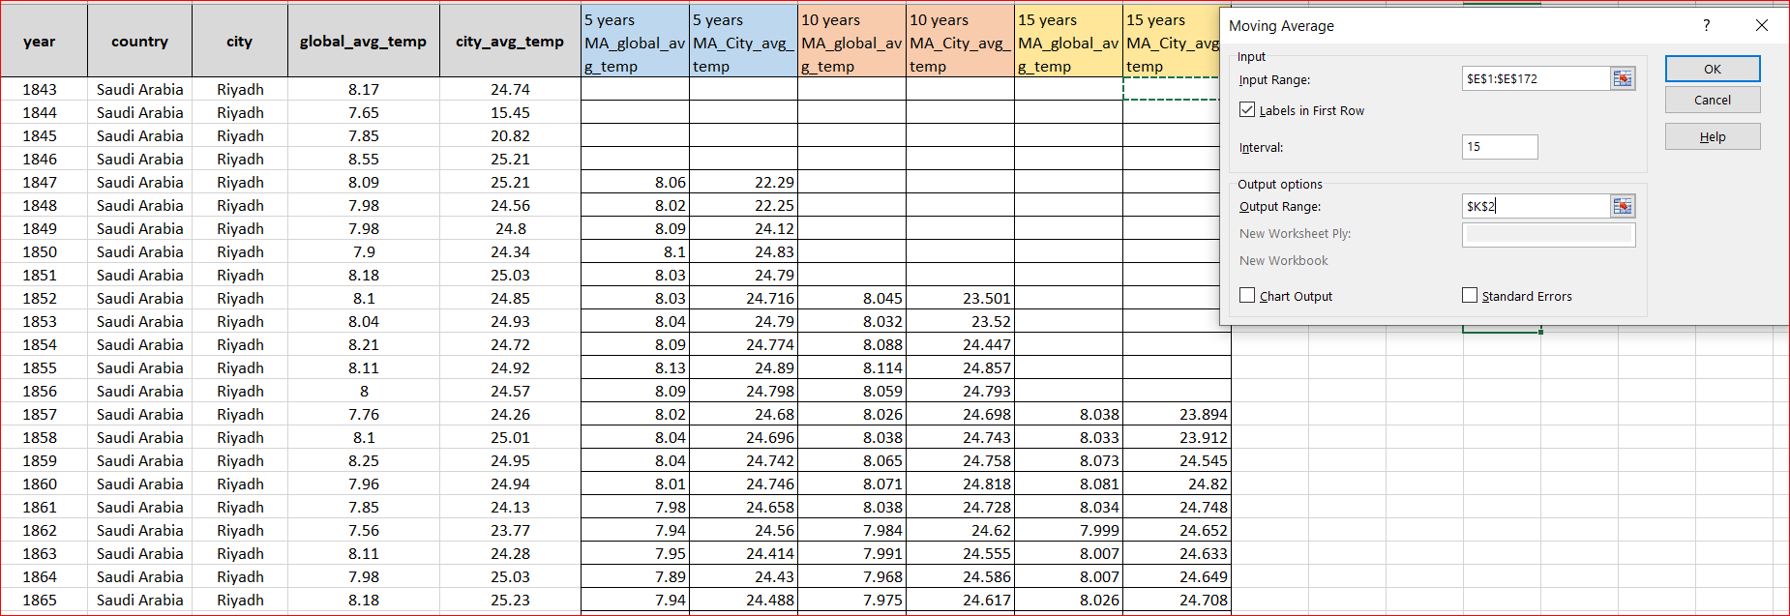

Visualization Global_avg_temp and City_avg_temp(5,10,15 years/MA)

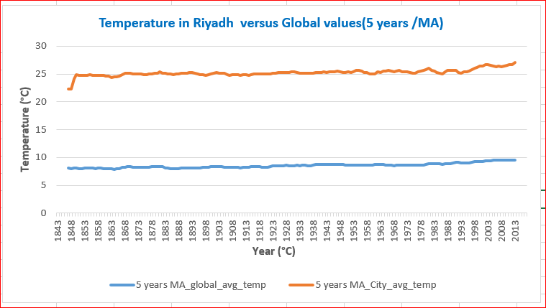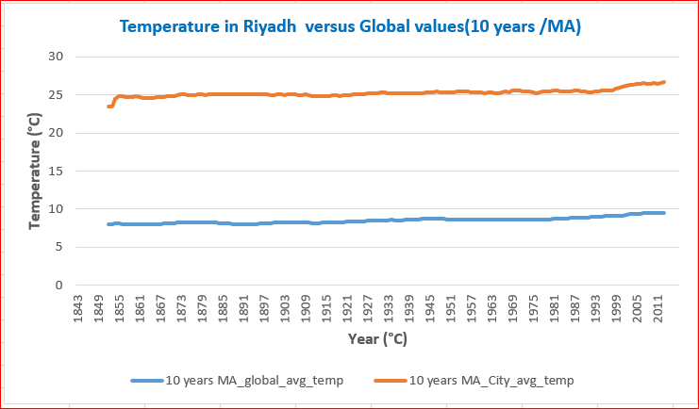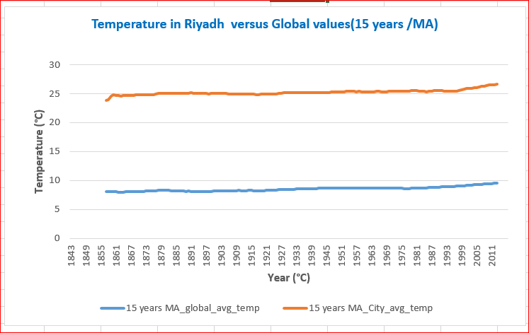

Observations:

1. There is an observable uptrend for Global temperatures averages and slightly uptrends for each of Riyadh city temperature averages.
2. With the passage of time and the simple moving average of five years was used to soften the data, we notice that temperatures in Riyadh rose from 22.23 to 24.8 so that they are the hottest and the global temperature was maintained at point 8,062 on average and we find a strong correlation between Correlation coefficient for Global_avg_temp and City_avg_temp(5 years/MA) =0.812437
3. With the passage of time and within a decade and the use of the simple moving average 10 years to soften the data, we note that the temperatures in Riyadh have risen from 23.508 to 24.787 so that they are the hottest and the global temperature was maintained at point 8.045 On average, we find a strong correlation between the correlation coefficient of Global_avg_temp and City_avg_temp (10 years / master's) = 0.899898
4. From the data, we note the increase in temperature in recent years. Riyadh recorded an average of only 26.64 and global 9.50 Global phenomena and their relationship to local weather in Saudi Arabia were addressed by several experts, where they explained that during the summer of 2007, Saudi Arabia went through free waves during which air temperatures in the shade rose to above 50 degrees Celsius, with local wind activity and natural effects, which may be one of the most important causes of global warming , And the phenomenon of ocean heating (El Nino), whose impact has decreased for the year 2013
5. The Kingdom of Saudi Arabia continues to record a significant increase in the degree of heat during the current years

*I hope to be home to the project requirements despite the valuable information that we learned from the lessons and also the project, but we do not know the exact correct result*

Help resources Forums: <https://knowledge.udacity.com>

**I wish success to all.**

M*arwan Saeed* *Alsharabbi*